Inter-VLAN Routing Exercise (Router-on-a-stick)
Topology:
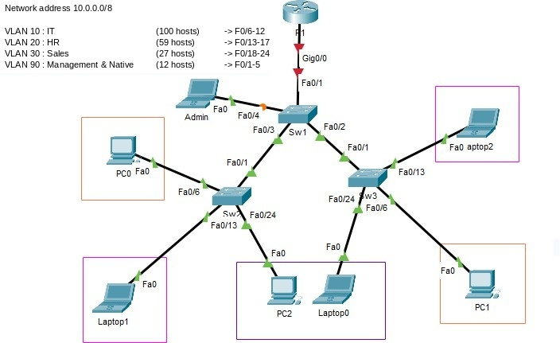
The local network is separated into VLANs according to the following table:

VLAN ID | VLAN Name | Ports
10 | IT | F0/6-12
20 | HR | F0/13-17
30 | Sales | F0/18-24
90 | Management | F0/1-5
- Using VLSM, reproduce and fill in the following table:
Knowing that:
  - The network address is: 10.0.0.0/8

Site | @Network | Mask | 1st Address | Last Address | Broadcast Address
IT (100h) | 10.0.0.0 | 255.255.255.128 | 10.0.0.1 | 10.0.0.126 | 10.0.0.127
HR (59h) | 10.0.0.128 | 255.255.255.192 | 10.0.0.129 | 10.0.0.190 | 10.0.0.191
Sales (27h) | 10.0.0.192 | 255.255.255.224 | 10.0.0.193 | 10.0.0.222 | 10.0.0.223
Management (12h) | 10.0.0.224 | 255.255.255.240 | 10.0.0.225 | 10.0.0.238 | 10.0.0.239
- Create and name the VLANs on the switches as shown in the mockup above.
- Configure the ports in Access mode.
- Configure the trunk ports (NB: native VLAN 90).
- Configure inter-VLAN routing on router R1.
- Configure the management interface on the switches.
- Configure remote access via Telnet on the switches and router R1

Verification:
Test connectivity, display the routing table on R1, and from the Admin laptop test remote access.

P r o f e s s o r Y o u s s e f P a g e 1 | 1

